Investments Problem Sheet 6 Lent Term 2024
True-false questions
- If you have split your portfolio between several managers, it is not important how much risk each manager takes because risks are likely to diversify away across managers.
- The value-weighted return on a portfolio is generally higher than the time-weighted return.
- If an actively managed equity portfolio has a Treynor measure of 8% per annum, then the same portfolio combined with a holding of risk free bonds will also have a Treynor measure of 8% per annum.
- If an actively managed equity portfolio has a Treynor measure of 8% per annum, then the same portfolio combined with a holding of an index fund will also have a Treynor measure of 8% per annum.
- If the CAPM holds, then a randomly chosen portfolio will have a Fama measure of zero.
- If the CAPM holds, then all other portfolios are expected to have a lower Sharpe ratio than the market portfolio.
Problems
- An equity fund has £100m under management at the beginning of the year. The following table shows the cash inflows (positive) and cash outflows (negative) that occur at the end of the year and at the end of the two subsequent years. It also shows the fund’s value after these cash flows, and the annual returns on the market portfolio and on T-bills.

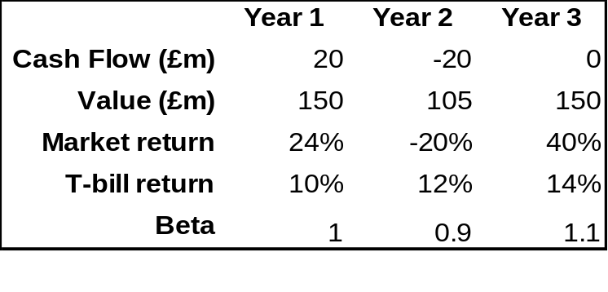
You estimate that the fund’s systematic variance was consistently equal to 85% of its total variance, and that the annualised standard deviation of market returns remained a constant 20% throughout the 3-year period.
- Calculate the time weighted return and the value weighted return on the fund over the three year period. Explain the difference in the two values.
- Calculate the total standard deviation of returns of the fund and the diversifiable standard deviation of the fund in each year.
- Calculate the Jensen and Fama measures and the Sharpe and Treynor ratios for the fund for each year.
- Comment on the performance of the fund.

2. A global equity manager is assigned to select stocks from a universe of large stocks throughout the world. The manager will be evaluated by comparing her returns to the return on the MSCI World Market Portfolio, but she is free to hold stocks from various countries in whatever proportions she finds desirable. Results for one month are given in the following table:
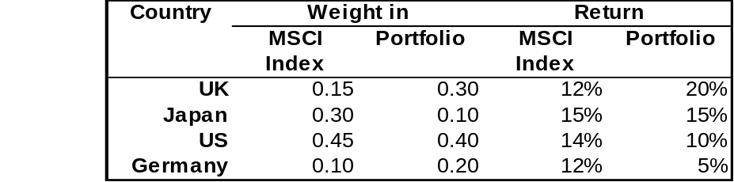
- Calculate the manager’s excess return on the portfolio as whole.
- Calculate the excess due to country allocation decisions.
- Calculate the excess due to stock selection within countries.
- Verify the sum of (b) and (c) is equal to (a).
- A portfolio P is invested in two assets A and B, with the remainder being invested in the market M. The diversifiable components of A and B are uncorrelated with each other. Over the last year, you have the following statistics, where T denotes T-bills in which the portfolio was not invested:
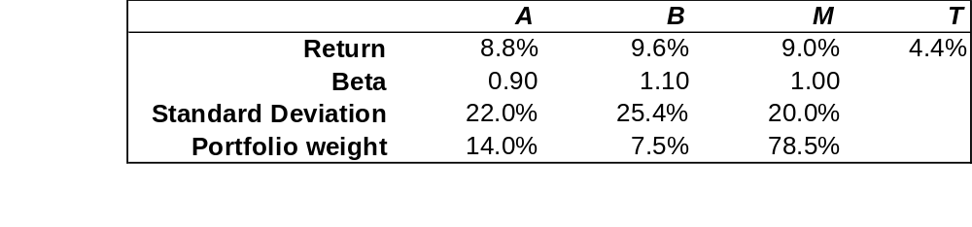
- compute the Jensen measure for each asset and for the portfolio as a whole
- Calculate the idiosyncratic standard deviation for both A and B.
- Calculate the portfolio’s beta, total standard deviation and idiosyncratic standard deviation.
- Calculate the Sharpe ratio of the portfolio and of the market.

